
INTERNET PROGRAMMING AND MOBILE
PROGRAMMING

PROJECT 3: Design and Implementation of a Crowdsensed Drive TestMobile Application for Coverage Prediction

TASK 4: SYSTEM MODELLING AND DESIGN

GROUP 10
GROUP MEMBERS
 | Name Of Member | Matricule
1 | Asangana Paul Fleming | FE23A014
2 | Fontem Junior Nkonganyik | FE23A063
3 | Suinyuy Mathias Mahla | FE23A144
4 | Nfor Godwill Kongnje | FE23A108
5 | Ronald Namwene Vefonge | FE22A295

TASK 4: SYSTEM MODELLING AND DESIGN 1
1. Purpose of the System Modelling and Design Phase 4
2. Overview of the Diagrams Developed 4
3. Explanation of the Design Phase 4
3.1 Data Flow Diagram 4
1. Data Flow Diagram in details 5
 Level 0 Data Flow Diagram (Context Diagram).......................................................................5
A. Mobile User 5
B. Admin / Network Analyst 5
 Level 1 Data Flow Diagram 6
Process 1: Collect Signal Data 6
Process 2: Store Data Locally 6
Process 3: Synchronize Data with Server 6
Process 4: Processing and Analyze Data 7
Process 5: Generate Reports and Coverage Maps 7
 Data Stores in the Diagram 7
A. Local Storage (SQLite) 7
B. Central Database 7
 Level 2 Data Flow Diagram 8
● Get Current GPS Location 8
● Scan Available Networks 8
● Step 3: Measure Signal Parameters 8
● Capture Additional Information 8
● Validate Data 9
● Flow of Data Through the System 9
● Importance of the Data Flow Diagram 9
3.2 Class Diagram ..........................................................................................................................10
3.3 Sequence Diagram 13
6. Components in the Diagram 13
3.4 User case Diagram ...................................................................................................................14
3.5 Deployment Diagram 16
4. Importance of the System Modelling and Design Phase 18
5. Conclusion 18

Introduction
The system modelling and design phase is one of the most important stages in software development. This phase focuses on representing the structure, behavior, data movement, interactions, and physical deployment of the system before implementation begins. For the Crowdsensed Drive Test Mobile Application for Coverage Prediction, different modelling diagrams were developed to describe how the application operates and how its components interact.

1. Purpose of the System Modelling and Design Phase
The purpose of the modelling and design phase is to provide a clear understanding of the system before coding begins. The diagrams created during this phase help developers, analysts, and stakeholders understand the logical and physical architecture of the application.
- Visualize the structure and behavior of the system
- Describe interactions between users and system components
- Explain data movement within the application
- Support software implementation and testing
- Reduce system design complexity
- Improve communication between project stakeholders

Overview of the Diagrams Developed
Diagram | Purpose
Context Diagram | Shows the overall interaction between external users and the system.
Data Flow Diagram | Explains how signal measurement data moves through the application.
Use Case Diagram | Illustrates the functions performed by users and administrators.
Sequence Diagram | Shows the order of interactions between system components during execution.
Class Diagram | Represents the structure of classes, attributes, and relationships within the system.

3. Explanation of the Design Phase

3.1 Data Flow Diagram
The Data Flow Diagram (DFD) of the Crowdsensed Drive Test Mobile Application explains how signal measurement data moves through the system from collection to coverage prediction and report generation.
The diagram shows:
- Sources of data
- Processes performed on the data
- Storage locations
- Outputs generated by the system

The system is designed to collect crowdsensed mobile network measurements from smartphone users to predict network coverage quality.

Data Flow Diagram in details
The DFD is divided into three main levels:
- Level 0 – Context Diagram
- Level 1 – Main Processes
- Level 2 – Detailed Breakdown of Signal Collection

Level 0 Data Flow Diagram (Context Diagram): The Level 0 diagram presents the entire application as one process called: “Crowdsensed Drive Test System”. This level shows the general interaction between users and the system. The system interacts with two external entities:

Mobile User
The mobile user sends:
- Signal strength data
- GPS location
- Device information
- Network information

The system returns:
- Coverage summaries
- Feedback
- Signal reports

B. Admin / Network Analyst
The administrator receives:
- Coverage maps
- Analytics reports
- Predicted coverage results

The administrator can also send:
- Configuration requests
- Analysis requests

CONTEXT DIAGRAM
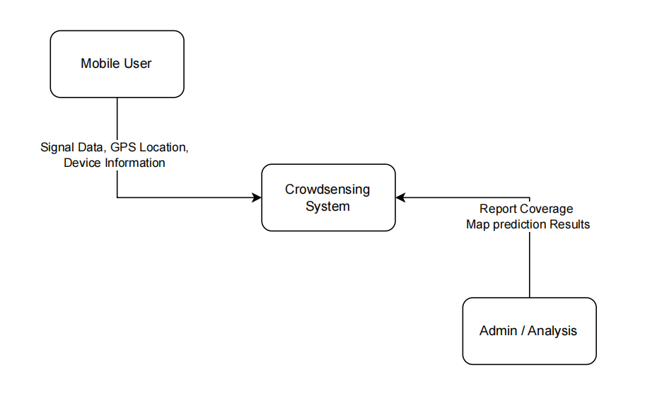

Level 1 Data Flow Diagram
The Level 1 DFD breaks the system into five major processes.

Process 1: Collect Signal Data
The mobile application collects network measurements from the smartphone.
The collected parameters include:
- RSSI
- RSRP
- RSRQ
- SINR
- Cell ID
- Network operator
- GPS coordinates
The collected data is forwarded to the next process.

Process 2: Store Data Locally
The collected measurements are stored temporarily in local storage using SQLite database.
This process helps:
- Prevent data loss
- Support offline operation
- Reduce synchronization failures
The stored data remains on the phone until internet access becomes available.

Process 3: Synchronize Data with Server
When internet connectivity is available, the application uploads stored measurements to the backend server.
The synchronization process includes:
- Uploading measurements
- Validating records
- Removing duplicates
- Confirming successful upload
The synchronized data is then transferred to the central database.

Process 4: Processing and Analyze Data
The backend server processes uploaded measurements.
The server performs:
- Data cleaning
- Signal analysis
- Statistical processing
- Coverage prediction
The system predicts signal quality in different geographical locations using crowdsensed measurements.
The processed data is stored in the central database.

Process 5: Generate Reports and Coverage Maps
The processed information is transformed into:
- Coverage maps
- Signal quality charts
- Analytics reports
- Prediction visualizations
These outputs are provided to the administrator for network analysis and decision-making.

Data Stores in the Diagram
The DFD contains two major data stores.

A. Local Storage (SQLite)
This storage exists on the smartphone.
It stores:
- Signal measurements
- GPS records
- Temporary synchronization data

B. Central Database
This database is located on the backend server.
It stores:
- Uploaded measurements
- User data
- Coverage prediction results
- Analytics reports
Possible technologies include:
- MySQL
- PostgreSQL

DATA FLOW DIAGRAM

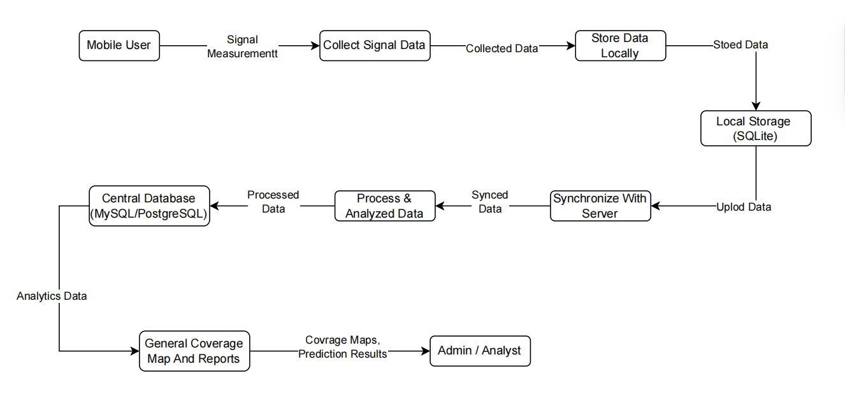

Level 2 Data Flow Diagram
The Level 2 DFD explains the “Collect Signal Data” process in more detail.

Get Current GPS Location
The application retrieves:
- Latitude
- Longitude
- Speed
- Time
This information identifies the exact location where measurements are collected.

Scan Available Networks
The smartphone scans nearby mobile networks such as:
- 2G
- 3G
- 4G
- 5G
- Wi-Fi
The system identifies available operators and connected towers.

Step 3: Measure Signal Parameters
The application measures network quality indicators including:
- RSSI
- RSRP
- RSRQ
- SINR
These values determine signal performance.

Capture Additional Information
Additional metadata is recorded such as:
- Device type
- Timestamp
- Operating system version
- User movement speed

Validate Data
The application checks whether:
- Data is complete
- GPS coordinates are valid
- Duplicate entries exist
- Measurements are corrupted
Validated data is then stored locally.

Flow of Data Through the System
The overall flow of data in the system is:
- User smartphone collects signal measurements
- Measurements are stored locally
- Data is synchronized with backend server
- Server processes and analyzes measurements
- Coverage prediction is performed
- Reports and maps are generated
- Results are displayed to administrators

Importance of the Data Flow Diagram
The DFD is important because it:
- Explains how the application works
- Shows movement of data clearly
- Simplifies system analysis
- Helps developers during implementation
- Assists database design
- Improves communication between stakeholders

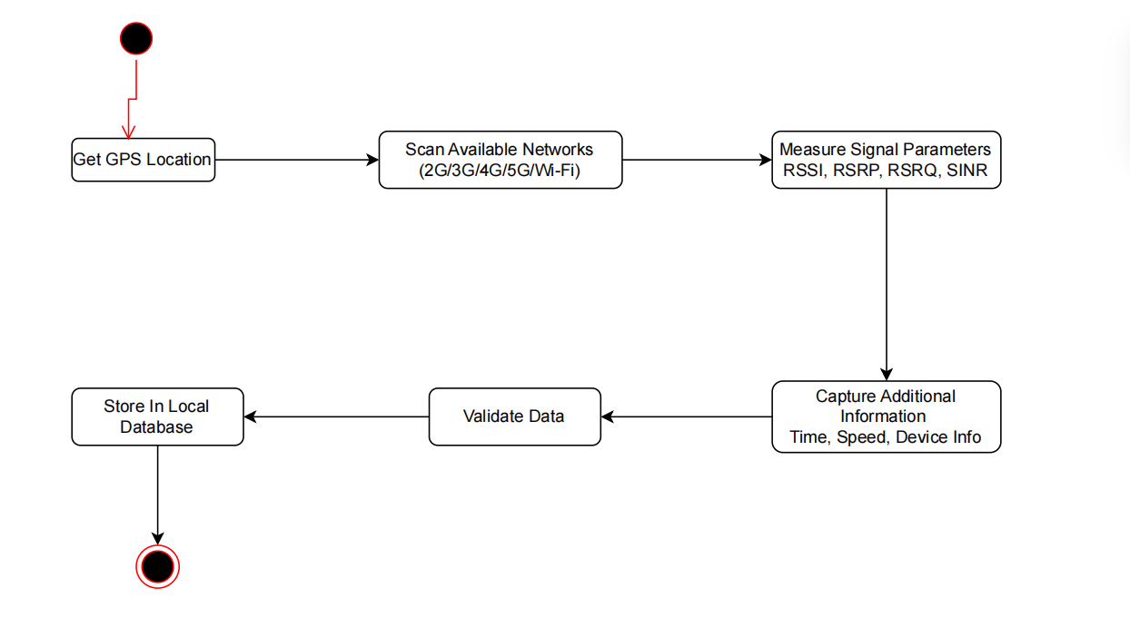

- The Data Flow Diagram of the Crowdsensed Drive Test Mobile Application provides a clear representation of how signal measurement data moves through the system. The diagram explains the processes involved in data collection, storage, synchronization, processing, analysis, and coverage prediction.

- The DFD serves as an important design tool that supports system development, implementation, and maintenance while improving understanding of the application’s operation.

3.2 Class Diagram
- The class diagram presents the structural design of the Crowdsensed Drive Test Mobile Application for Coverage Prediction. It illustrates the major system classes, their attributes, methods, and the relationships between them. The diagram provides a blueprint for implementing the application using object-oriented design principles.

- The system is centered around the collection, storage, processing, analysis, and visualization of mobile network measurements gathered from smartphone users through crowdsensing techniques. Each class represents a major component of the application and contributes to the overall functionality of the system.

- The User class represents smartphone users who interact with the mobile application. Users are responsible for registering, logging into the system, uploading collected measurements, and viewing coverage maps. The class stores basic user information such as user ID, name, email, password, and location permission settings.

- The SignalMeasurement class represents network-related measurements collected from smartphones. This class stores technical parameters such as RSSI, RSRP, RSRQ, SINR, network type, and timestamps. It forms the core data collection component of the application because the collected measurements are used for network analysis and coverage prediction.

- The GPSLocation class stores geographical coordinates associated with each signal measurement. It contains latitude, longitude, and region information that allow the system to identify the exact location where measurements are collected. This class supports location-based analysis and map visualization.

- The LocalStorage class manages temporary offline storage of collected measurements. Since users may travel through areas with poor or unstable internet connectivity, measurements are first stored locally on the smartphone before synchronization with the backend server occurs. This helps prevent data loss during offline operation.

- The BackendServer class represents the centralized server responsible for receiving, validating, cleaning, and processing crowdsensed measurements. It acts as the core processing component of the system and communicates with the database and analytics modules.

- The CoverageAnalysis class processes collected measurements to evaluate network quality and identify weak coverage regions. The analyzed data is then passed to the CoveragePrediction class, which predicts mobile network coverage conditions across different geographical locations.

- The Report class generates analytical reports based on processed measurements and prediction results. Reports may include coverage summaries, signal quality statistics, and network performance trends. The generated reports are then visualized using the CoverageMap class, which displays graphical representations such as maps and heat maps.

- The Admin class represents administrators responsible for monitoring system activities, managing reports, and controlling backend operations.

Several relationships exist between the classes. A user can collect multiple signal measurements, while each signal measurement contains one GPS location. Measurements are stored locally and later synchronized with the backend server. The backend server analyzes the collected data, generates predictions, produces reports, and visualizes results through coverage maps. Administrators manage backend services and system operations.
The class diagram therefore provides a clear representation of the internal structure of the system and serves as a foundation for software implementation, testing, maintenance, and future system expansion.

CLASS DIAGRAM

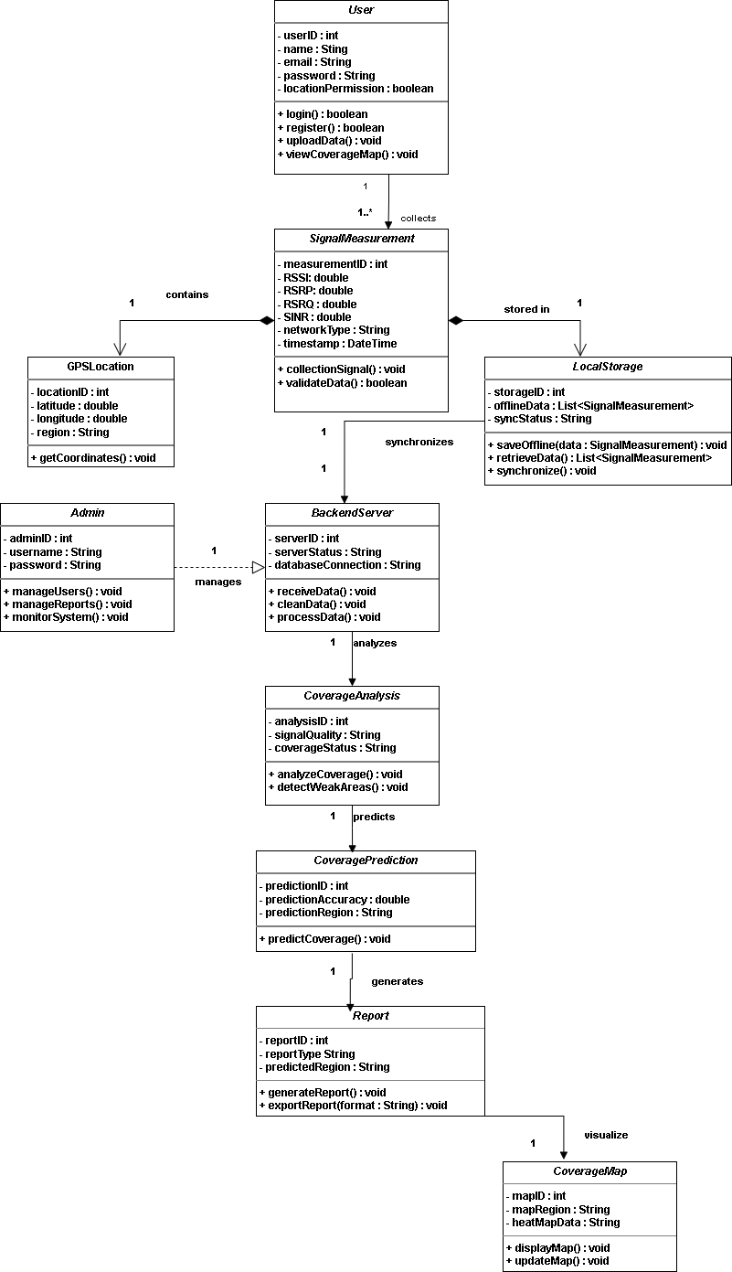

3.3 Sequence Diagram
The sequence diagram illustrates how the Crowdsensed Drive Test Mobile Application interacts with system sensors and local storage during signal data collection and storage.

1. User Launches the Mobile Application
The sequence begins when the user launches the mobile application. The mobile app immediately starts a background service responsible for continuous signal monitoring.

2. Background Service Initialization
After the application starts, the mobile app initiates the background service. This service runs automatically and performs periodic signal data collection without requiring user interaction.

3. Periodic Signal Collection Loop
Inside the loop section of the diagram, the application requests signal information from the system sensors every specified number of minutes. The sensors return network measurements such as RSRP, RSRQ, and GPS coordinates.

4. Internet Unavailable Condition
The alternative (alt) section shows the behavior of the application when internet connectivity is unavailable. The mobile application stores the collected signal measurements in local storage using the storeData() operation. After successful storage, a confirmation message is returned to the application.

5. Internet Available Condition
When internet connectivity becomes available, the application queues the locally stored data for synchronization with the backend server. This ensures that measurements collected offline are not lost and can later be uploaded for coverage prediction analysis.

Components in the Diagram

Actor | Role Description
User | The smartphone owner who interacts with the mobile app (e.g., logs in, opens the map view) and receives notifications about poor signal areas or sync failures.
OS Timer | A built-in system clock that wakes up the background service at regular intervals (e.g., every 30 seconds) to trigger signal data collection.
Background Service | A silent worker component of the mobile app that runs in the background, collects signal and location data, manages local storage, handles synchronization, and schedules retries when sync fails.
Telephony API | A system-level interface provided by the Android OS that supplies real-time mobile network metrics such as RSSI, RSRP, RSRQ, SINR, and network type.
Location API | A system-level interface that provides the device’s current GPS coordinates (latitude, longitude, accuracy, timestamp).
Local DB | An internal, offline-first database (e.g., SQLite/Room) on the smartphone that temporarily stores unsynced measurements until internet connectivity is restored.
Backend Server / Backend API / Auth Service | The central cloud-based server that receives crowdsensed data via HTTPS, validates and stores it, handles authentication (JWT tokens), and serves coverage data to the mobile app. (Different names in diagrams refer to the same logical backend.)
Backend / DB | The persistent database on the server side that stores user credentials (hashed) and all validated network measurements.
Analytics Engine | A backend processing component that converts raw measurement rows into a heatmap grid by performing interpolation (estimating signal strength between measured points) and classification (assigning quality levels: poor, moderate, strong).
Alert Engine | A rule-based backend component that checks each incoming measurement against signal thresholds (e.g., RSSI < -110 dBm) and creates alert objects (zone, severity, coordinates) when thresholds are breached.
Push Service | A messaging service (e.g., Firebase Cloud Messaging) that delivers real-time push notifications to the user’s device when a poor signal zone is detected or when a sync failure occurs.

A system timer wakes the background service at regular intervals (every 30 seconds) and calls the Telephony API to obtain current network metrics (RSSI, RSRP, RSRQ, SINR, network type). It then calls the Location API to fetch GPS coordinates (latitude, longitude, accuracy, timestamp). All data are bundled into a single measurement object.
Finally, the measurement is stored silently in the local database without any user interaction.

If no internet connectivity is available, the background service inserts the measurement directly into the local database. Once connectivity is restored, the service queries the database for all unsynced measurements. The unsynced data are batched and sent via an HTTPS POST request to the backend server. The server validates and stores the data, then returns a success response with the count of synced records. The service marks those records as synced in the local database so they are never uploaded again.

When the user opens the map view inside the mobile application, the app requests coverage data from the backend API using a bounding box of the visible map area (GET /coverage?bbox=...). The backend queries the database for raw measurement rows inside that area and passes them to the analytics engine. The analytics engine interpolates missing values and classifies signal quality, producing a heatmap grid of {latitude, longitude, quality}. The backend returns the heatmap data to the app, which renders a colored overlay (e.g., red = poor, green = good) on the user’s map.

After a measurement is successfully synced, the backend API forwards it to the alert engine.
If the signal strength (e.g., RSSI) falls below a defined threshold, the alert engine creates an alert (zone, severity, coordinates). The alert engine instructs the notification service to send a push notification to the user’s device. If a sync failure occurs (e.g., the backend cannot be reached), the backend returns a failure reason, and the background service schedules a retry with exponential backoff. The user is notified locally about the sync failure, while push notifications warn them about poor coverage zones.

3.4 Use Case Diagram
The Use Case Diagram models the functional requirements of the proposed UX Network Data Collection App. It defines the system boundary, the external actors interacting with the application, and the relationships between various functionalities. This model ensures that all background data management processes correspond directly to system requirements.

1. System Boundary
The system boundary encompasses the mobile client-side storage cache, background monitoring processes, and backend analysis engines. It isolates internal system functions from the external human roles interacting with the platform.

2. Actors Identification
The system contains two primary human roles:
- Mobile User (Subscriber): The primary actor running the mobile application. This role initiates real-time, background network parameters capturing and network synchronization events.

- Admin / Analyst: The secondary administrative actor who interacts with the backend server management interfaces to control system resources, review metrics, and generate network performance diagnostics.

3. Use Case Specifications & Relationships
A. Core Mobile User Functions
- Collect Signal Data: Captures critical device network states (such as RSSI, RSRP, RSRQ, and GPS location coordinates). It executes automatically or through manual invocation.

- Synchronize Data with Server: Safely pushes the records gathered over time out to the cloud platform database when a stable cellular data or Wi-Fi network connection is established.

- Store Data Locally (SQLite) <<include>>: A foundational subsystem process. Both Collect Signal Data and Synchronize Data with Server depend on it because raw metrics must be cached locally inside an on-device SQLite database container before any web transfers take place.

B. Core Administrative Functions
- Process & Analyze Data: Triggered or managed by the Admin/Analyst to compute network data anomalies, calculate signal trends, and organize telemetry data into historical trend models.

- View Coverage Maps & Reports: Aggregates and transforms raw geospatial metrics into intuitive visual heat maps, enabling engineers to spot dead zones or signal quality drops.

4. Summary of Architectural Integrity
By directly mapping your original Level 1 Data Flow Diagram (DFD) to this Use Case diagram, your architecture guarantees complete consistency. Your DFD endpoints correspond exactly with these actor interactions, and no processes are missing connections.

USE CASE DIAGRAM
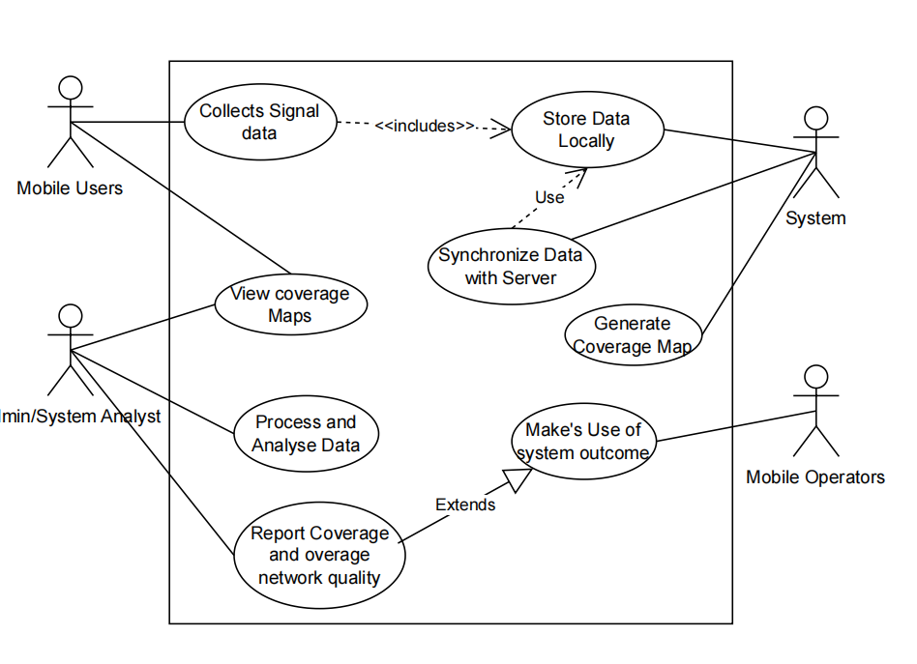

3.5 Deployment Diagram
The deployment diagram explains how the components of the Crowdsensed Drive Test Mobile Application are physically deployed and how they communicate during coverage prediction operations.

1. Mobile Device Node
The mobile device represents the smartphone running the Crowdsensed Drive Test Application. The application collects signal measurements such as RSSI, RSRP, RSRQ, SINR, GPS coordinates, and network information. The device also stores measurements locally when internet connectivity is unavailable.

2. Backend Server Node
The backend server receives uploaded signal measurements from the mobile application through the internet. The server validates, processes, and analyzes the collected crowdsensed data. It also performs coverage prediction and generates analytics results.

3. Database Server Node
The database server stores all uploaded measurements and processed information. It maintains signal records, GPS data, user information, prediction results, and generated reports. The backend server communicates directly with the database during analysis.

4. Admin / Analyst System Node
The admin or analyst system represents the web dashboard used for monitoring and analysis. Administrators use the dashboard to view coverage maps, analyze network quality, and generate reports based on the processed crowdsensed data.

DEPLOYMENT DIAGRAM
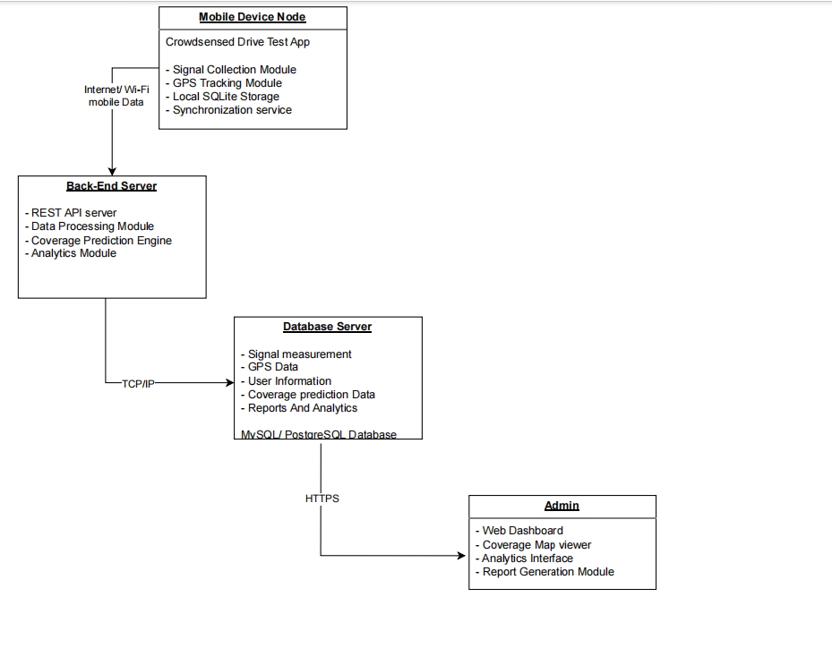

5. Communication Between Components
The mobile application communicates with the backend server through mobile data or Wi‑Fi. The backend server exchanges information with the database server using TCP/IP communication. The admin dashboard accesses reports and prediction results from the backend server through HTTPS.

6. Flow of Operations in the Deployment Diagram
- The mobile application collects signal measurements from the smartphone sensors.
- Collected measurements are stored locally on the mobile device.
- When internet connectivity becomes available, the data is uploaded to the backend server.
- The backend server processes and analyzes the uploaded measurements.
- Processed information is stored in the database server.
- Coverage prediction results and reports are generated.
- Administrators access coverage maps and reports through the web dashboard.
The deployment diagram clearly shows how the mobile application, backend server, database server, and admin dashboard interact during crowdsensed signal collection and coverage prediction. It explains the physical structure of the system and the communication flow between all deployed components.

4. Importance of the System Modelling and Design Phase
- Provides a clear blueprint for implementation
- Improves understanding of the system architecture
- Simplifies communication between developers and stakeholders
- Supports maintenance and future upgrades
- Helps identify system requirements early
- Reduces implementation errors and complexity

5. Conclusion
The system modelling and design phase provided a complete representation of the Crowdsensed Drive Test Mobile Application for Coverage Prediction before implementation. The diagrams developed during this phase explained the structure, behavior, interactions, data movement, and physical deployment of the system. Together, the Context Diagram, Data Flow Diagram, Use Case Diagram, Sequence Diagram, Class Diagram, and Deployment Diagram created a strong foundation for software development, testing, maintenance, and future expansion of the application.

